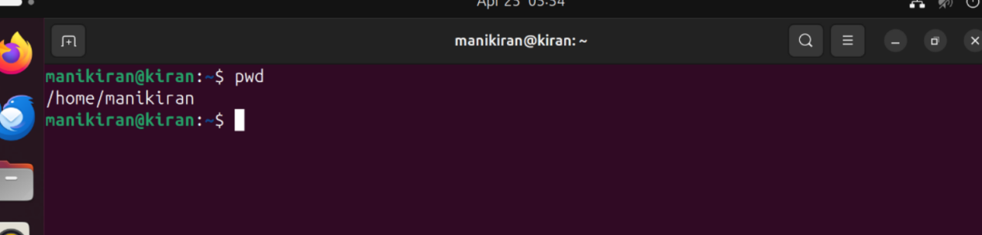

PWD:present working directory

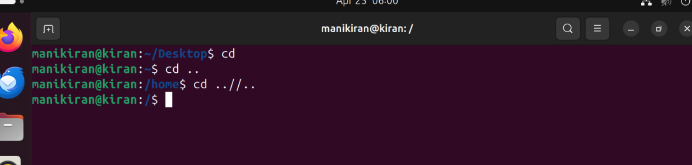

cd:change one to another directory

cd .. :one step back to directory

cd ../.. :two step back to directory

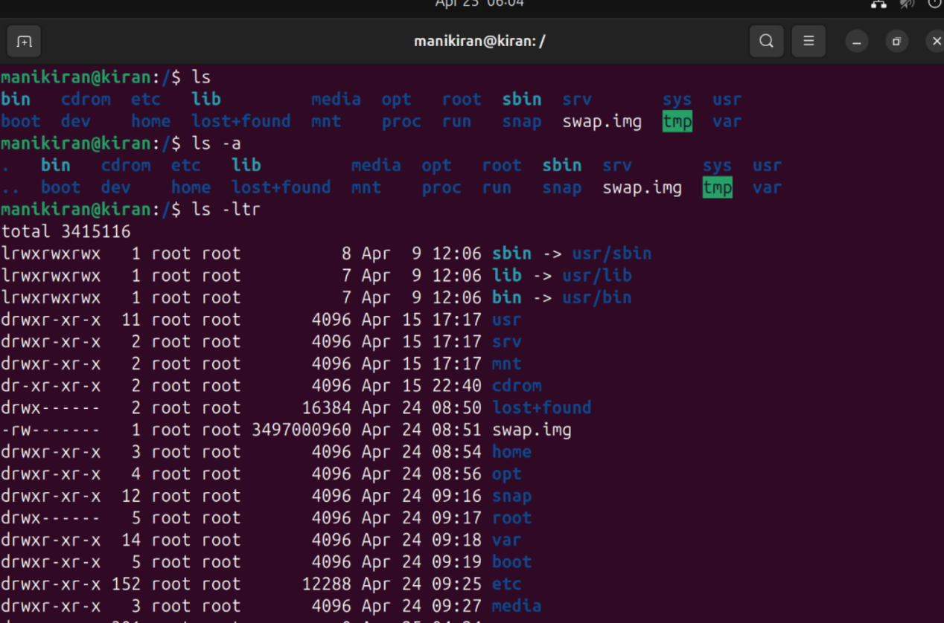

ls:list of files

ls -a:list of hidden files

ls -ltr:list of according to time of recent created files

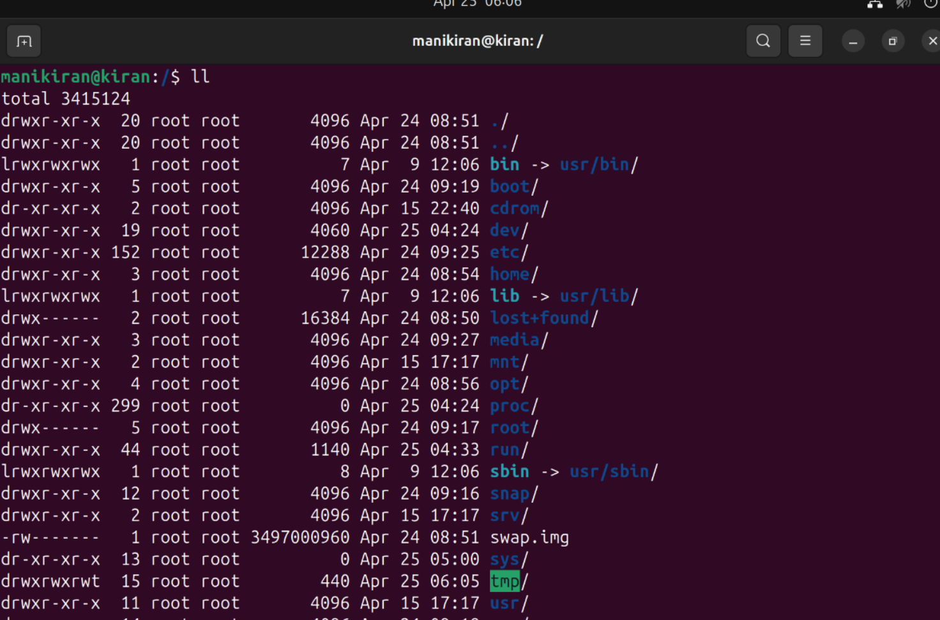

LL:long list

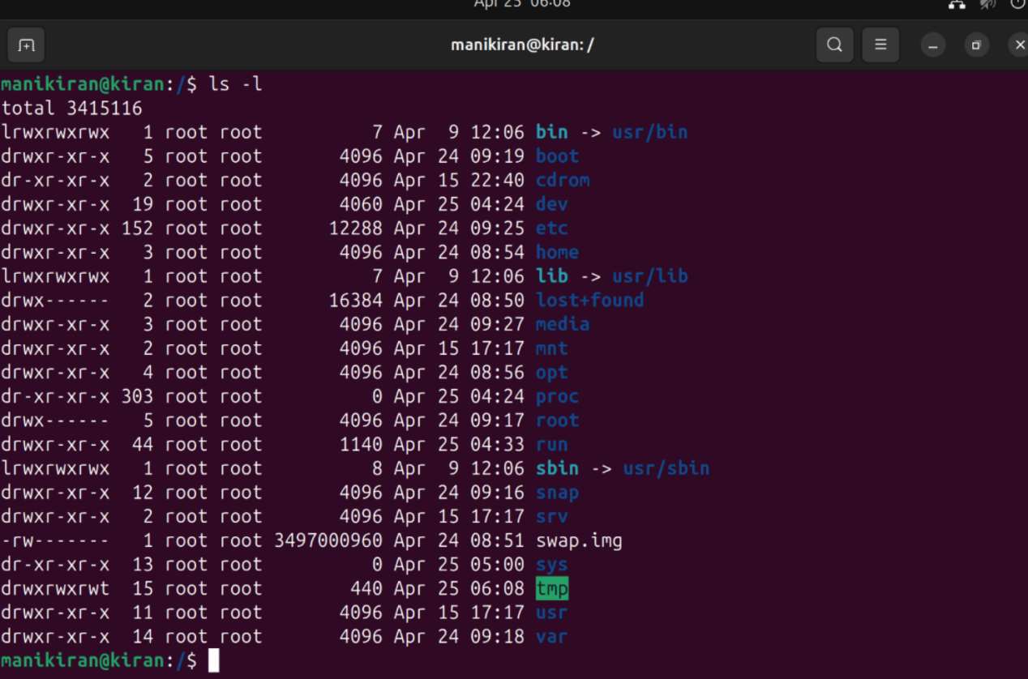

ls -l:to show the complete list

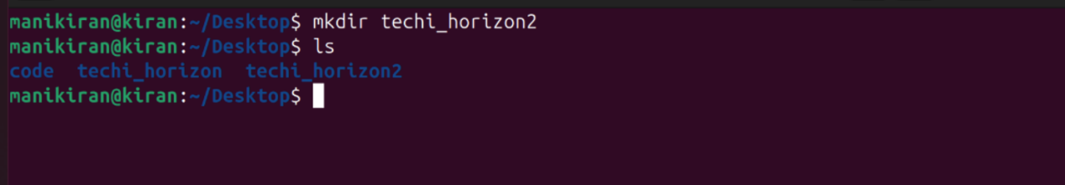

mkdir:it is uded to create file directory

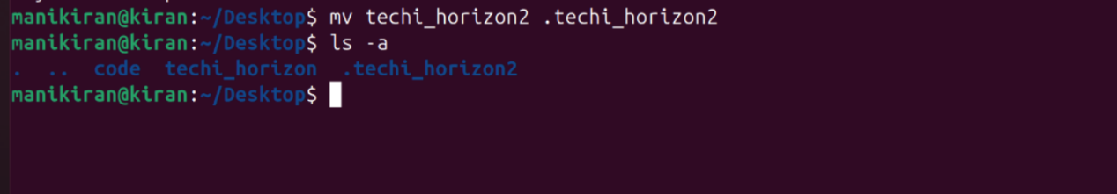

mv: move the file “.” if we add dot before the file the file will hidden

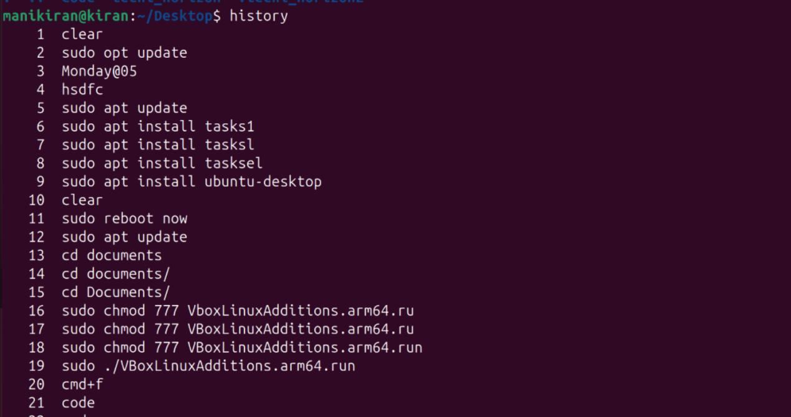

history:it will show the past history



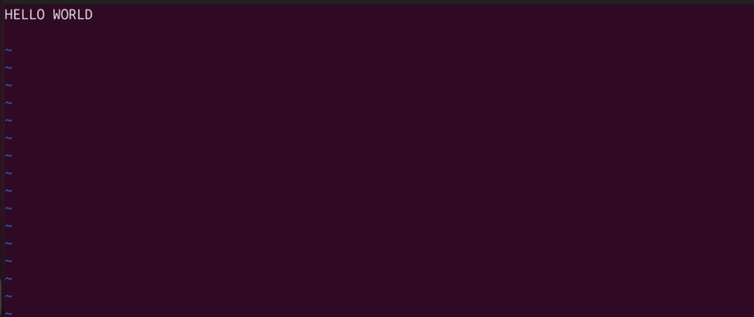

vi :is to create text file

:wq!:is to exit from text file

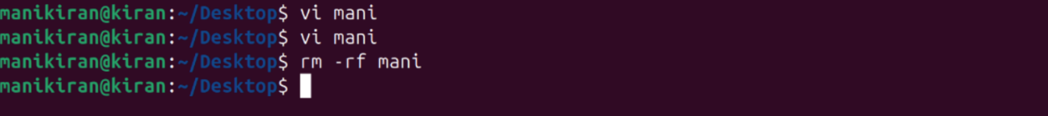

rm -rf :it is to remove file



date :it will show date and time

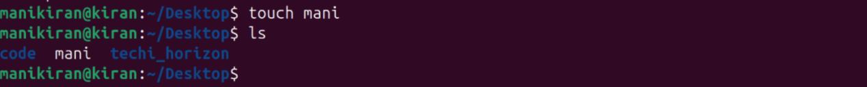

Touch:to create a file

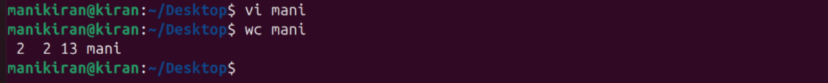

wc :it will the word count and lines

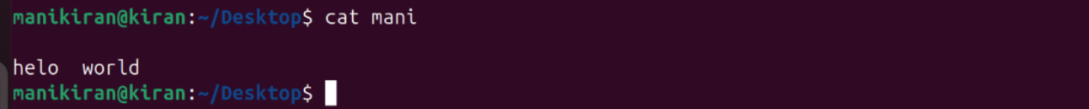

cat:to read the content

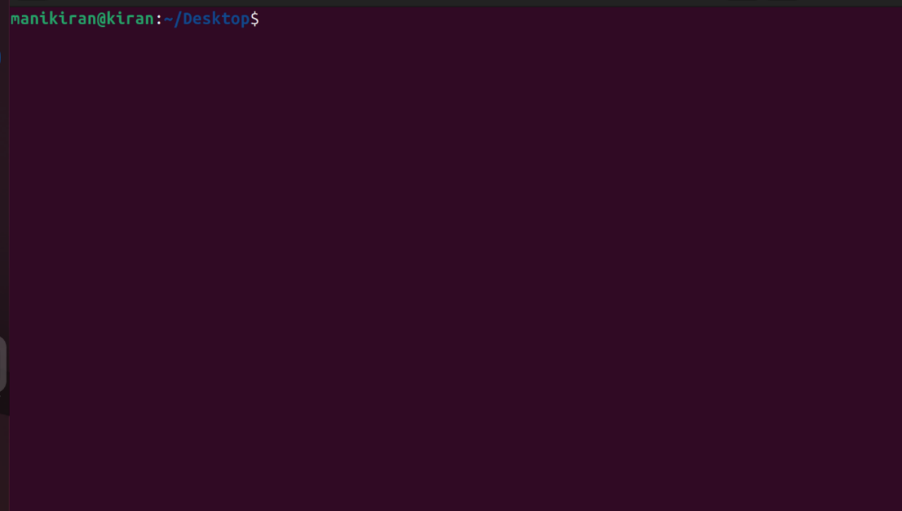

clear:clear the cammand